SeShop Project
Version 1.0
SOFTWARE REQUIREMENTS SPECIFICATION
SeShop
Revision and Sign Off Sheet
Change Record
Author | Version | Change reference | Date
Previous Team | 0.1 | Legacy baseline | 05/01/2024
GitHub Copilot (GPT-5.3-Codex) | 0.2 | Omnichannel scope adaptation from BRD | 27/03/2026
GitHub Copilot (GPT-5.3-Codex) | 1.0 | Final SRS draft with PlantUML activity flows | 27/03/2026
Table of Contents
1. Introduction
1.1. Purpose
1.2. Scope
1.3. Intended Audiences and Document Organization
2. Functional Requirements
2.1. Use Case Description
UC1: Create custom role
UC2: Assign permission to role
UC3: Assign or revoke role for staff
UC4: View audit logs
UC5: Add product and SKUs
UC6: Adjust SKU inventory
UC7: Transfer stock between locations
UC8: Process POS sale
UC9: Process refund
UC10: Manage discount codes
UC11: Compose Instagram draft
UC12: Register account
UC13: Browse and filter variants
UC14: AI recommendation chat
UC15: Checkout and pay
UC16: View stock by location
UC17: Track shipment
UC18: Leave review with image
UC19: View pending online orders
UC20: Mark order as shipped with tracking
UC21: Connect or reconnect Instagram account
UC22: Purchase order and stock receiving
UC23: Allocate order to fulfillment location
UC24: Return intake and exchange
UC25: Cycle count and inventory reconciliation
UC26: POS shift close and cash reconciliation
UC27: Generate tax invoice and adjustment note
2.2. List Description
2.3. View Description
2.4. Requirements Traceability Matrix
3. Non-functional Requirements
3.1. User Access and Security
3.2. Performance Requirements
3.3. Implementation Requirements
4. Appendixes
Glossary
Messages
Issues List

Introduction

Purpose
This document is the Software Requirements Specification (SRS) for the SeShop project. It translates approved business requirements into functional and non-functional specifications for engineering, QA, operations, and stakeholder review.
The document is intended to be the baseline for implementation planning, test design, release validation, and acceptance.

Scope
The scope includes a single-business omnichannel clothing and accessories platform with:
- Storefront shopping and account management.
- Multi-location inventory management with STORE and STORAGE nodes.
- Role-based staff operations and immutable audit logs.
- Order, shipment, POS, and refund workflows.
- Discount management and social compose workflow for Instagram.
- AI recommendation chat integrated with live stock context.
Out of scope for v1:
- Multi-vendor marketplace.
- Loyalty points and gift cards.
- Automated direct social publishing without manual review gate.

Intended Audiences and Document Organization
This document is intended for:
- Development Team: implement APIs, services, and UI modules based on UC and BR details.
- QA/UAT Team: derive test cases from business rules and acceptance behavior.
- Product/Business Team: validate scope and operation alignment.
- Operations/Security Team: review access matrix, auditability, and service constraints.
Main sections:
- 1. Introduction: Project goal and scope.
- 2. Functional Requirements: Use cases, activity flows, and business rules.
- 3. Non-functional Requirements: Security, performance, and implementation constraints.
- 4. Appendixes: Glossary, messages, and unresolved items.

Functional Requirements

Use Case Description

UC1: Create custom role
Name | Create custom role
Description | Super Admin creates a role for single-function or grouped-function operations.
Actor | Super Admin
Trigger | Clicks Access Management > Create Role.
Pre-condition | Super Admin is authenticated and authorized.
Post-condition | New role is created and audit log is written.

Activities Flow
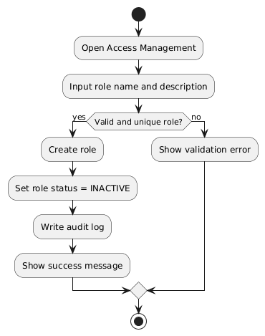
PlantUML Diagram

Business Rules
Activity | BR Code | Description
Validate input | BR1 | roleName is required and unique.
Create role | BR2 | Role starts as INACTIVE until at least one permission is assigned.
Audit | BR3 | System records actor, action, target role ID, timestamp, and IP metadata.

UC2: Assign permission to role
Name | Assign permission to role
Description | Super Admin maps atomic permissions to a custom role.
Actor | Super Admin
Trigger | Clicks Role Detail > Assign Permission.
Pre-condition | Role exists. Permission catalog exists.
Post-condition | Role permission set is updated and logged.

Activities Flow
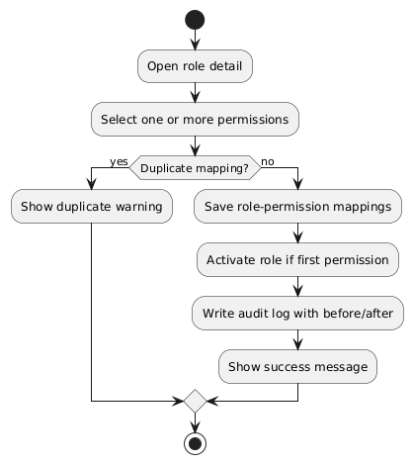
PlantUML Diagram

Business Rules
Activity | BR Code | Description
Validate mapping | BR4 | Duplicate role-permission entries are not allowed.
Update status | BR5 | Role can transition to ACTIVE when at least one permission exists.
Propagation | BR6 | Permission change is effective within configured SLA.

UC3: Assign or revoke role for staff
Name | Assign or revoke role for staff
Description | Super Admin manages role assignment lifecycle for staff.
Actor | Super Admin
Trigger | Clicks Staff Detail > Manage Roles.
Pre-condition | Staff account exists and is active.
Post-condition | Staff effective permissions are updated and logged.

Activities Flow
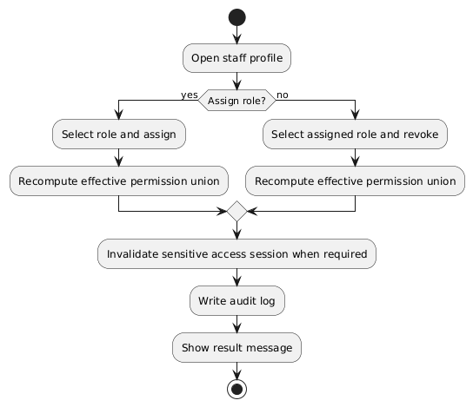
PlantUML Diagram

Business Rules
Activity | BR Code | Description
Assignment | BR7 | Only active roles can be assigned.
Revocation | BR8 | Critical permission revocation is effective immediately.
Access model | BR9 | Staff can hold multiple roles; effective permissions are union of assigned roles.

UC4: View audit logs
Name | View audit logs
Description | Super Admin reviews immutable logs for governance and compliance.
Actor | Super Admin
Trigger | Clicks Access Management > Audit Logs.
Pre-condition | Admin has audit.read permission.
Post-condition | Filtered logs are displayed/exported.

Activities Flow
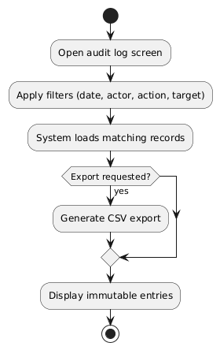
PlantUML Diagram

Business Rules
Activity | BR Code | Description
Integrity | BR10 | Audit records are append-only and cannot be edited/deleted from UI.
Query | BR11 | Filtering by date range, actor, action, and target entity is required.
Export | BR12 | CSV export is restricted to authorized admins.

UC5: Add product and SKUs
Name | Add product and SKUs
Description | Staff creates product master and variant SKUs for sale channels.
Actor | Authorized Staff
Trigger | Clicks Catalog > Add Product.
Pre-condition | Staff has catalog.write permission.
Post-condition | Product and SKUs are created and visible based on publish status.

Activities Flow
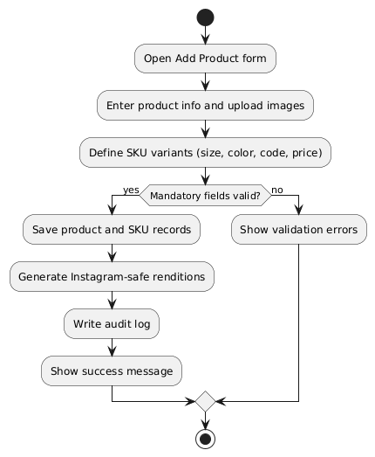
PlantUML Diagram

Business Rules
Activity | BR Code | Description
Validation | BR13 | Product must have title, category, base price, and at least one image.
SKU identity | BR14 | SKU code is unique within system scope.
Media | BR15 | Original media is preserved; Instagram-compatible rendition is generated for compose flow.

UC6: Adjust SKU inventory
Name | Adjust SKU inventory
Description | Staff performs stock corrections per SKU and location.
Actor | Authorized Staff
Trigger | Clicks Inventory > Adjust.
Pre-condition | SKU and location exist.
Post-condition | Inventory balance is updated with reason trace.

Activities Flow
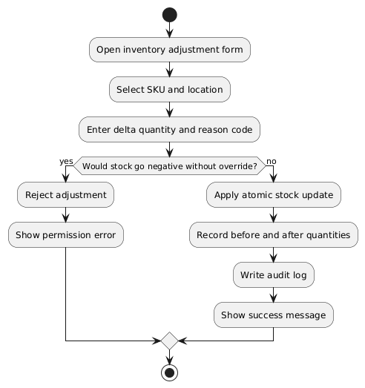
PlantUML Diagram

Business Rules
Activity | BR Code | Description
Reason code | BR16 | Adjustment reason is mandatory.
Safety | BR17 | Negative stock requires explicit override permission.
Consistency | BR18 | Inventory update is atomic per SKU-location.

UC7: Transfer stock between locations
Name | Transfer stock between locations
Description | Staff creates and completes inventory transfer between nodes.
Actor | Authorized Staff
Trigger | Clicks Inventory > Transfer.
Pre-condition | Source has enough available quantity.
Post-condition | Transfer status trail is updated and destination stock is increased on completion.

Activities Flow
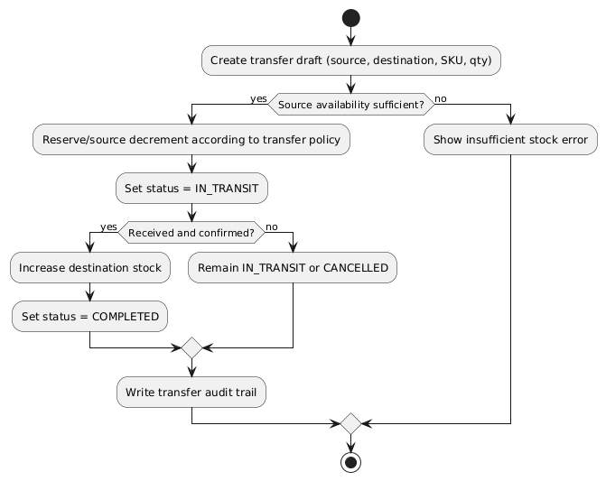
PlantUML Diagram

Business Rules
Activity | BR Code | Description
Transfer model | BR19 | Statuses:DRAFT, IN_TRANSIT, COMPLETED, CANCELLED.
Completion | BR20 | Destination inventory is updated only when transfer is COMPLETED.
Traceability | BR21 | Every status transition is audited.

UC8: Process POS sale
Name | Process POS sale
Description | Staff completes in-store sale and synchronizes inventory centrally.
Actor | Authorized Staff
Trigger | Clicks POS > Checkout.
Pre-condition | POS session active and cashier authorized.
Post-condition | Receipt is issued and stock is decremented atomically.

Activities Flow
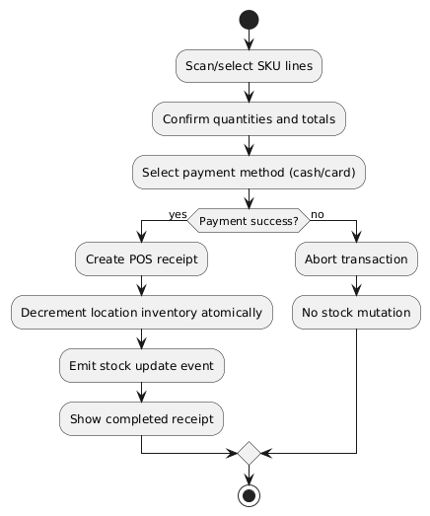
PlantUML Diagram

Business Rules
Activity | BR Code | Description
Atomicity | BR22 | Receipt creation and stock decrement are in one transactional boundary.
Failure handling | BR23 | On payment failure, transaction is rolled back.
Synchronization | BR24 | POS completion emits inventory synchronization event.

UC9: Process refund
Name | Process refund
Description | Staff processes full or partial refund for eligible transactions.
Actor | Authorized Staff
Trigger | Clicks Orders/POS > Refund.
Pre-condition | Original paid transaction exists and is refundable by policy.
Post-condition | Refund record exists and stock is restored as policy dictates.

Activities Flow
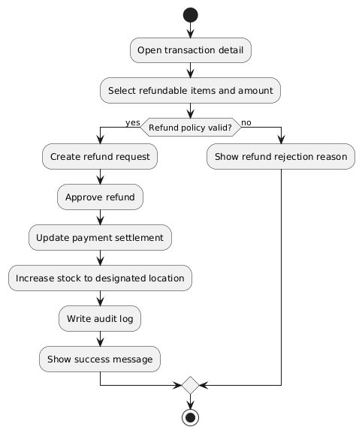
PlantUML Diagram

Business Rules
Activity | BR Code | Description
Coverage | BR25 | System supports full and partial refunds.
Linkage | BR26 | Refund must reference original order or POS receipt.
Stock | BR27 | Approved return increases stock at configured location.

UC10: Manage discount codes
Name | Manage discount codes
Description | Staff creates and controls promotional codes.
Actor | Authorized Staff
Trigger | Clicks Promotions > Discount Codes.
Pre-condition | Staff has promotion management permission.
Post-condition | Discount code is created/updated and available for validation at checkout.

Activities Flow
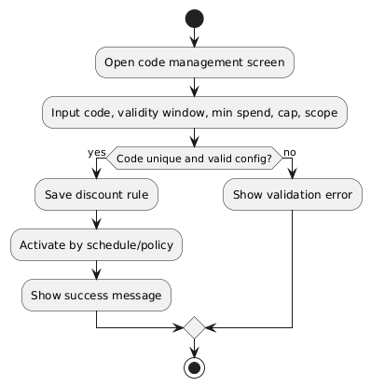
PlantUML Diagram

Business Rules
Activity | BR Code | Description
Uniqueness | BR28 | Discount code must be globally unique.
Stacking | BR29 | v1 supports single-code per order; stacking is not allowed.
Constraints | BR30 | Rule can include validity period, usage cap, and minimum spend.

UC11: Compose Instagram draft
Name | Compose Instagram draft
Description | Staff generates and edits a compose-ready Instagram draft from product data.
Actor | Authorized Staff
Trigger | Clicks Marketing > Create Instagram Draft.
Pre-condition | Product media exists. Staff has marketing permission.
Post-condition | Draft caption and media ordering are saved for manual publishing.

Activities Flow
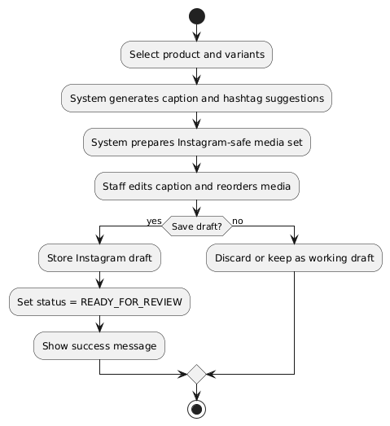
PlantUML Diagram

Business Rules
Activity | BR Code | Description
Editability | BR31 | Caption and image ordering must be editable before publish handoff.
Approval gate | BR32 | No automatic publish is allowed without manual approval.
Asset compliance | BR33 | Draft uses Instagram-compatible image versions when available.

UC12: Register account
Name | Register account
Description | Customer creates a new SeShop account.
Actor | Customer
Trigger | Clicks Sign Up.
Pre-condition | Customer is unauthenticated.
Post-condition | Account is created and verification workflow is initiated.

Activities Flow
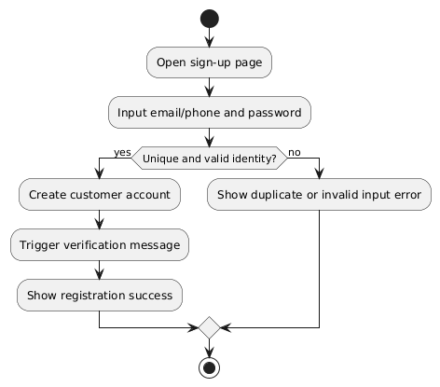
PlantUML Diagram

Business Rules
Activity | BR Code | Description
Identity uniqueness | BR34 | Email and phone number must be unique.
Verification | BR35 | Verification flow can be enabled by policy.
Security | BR36 | Password policy requires minimum complexity.

UC13: Browse and filter variants
Name | Browse and filter variants
Description | Customer filters and compares product variants to decide purchase.
Actor | Customer
Trigger | Uses storefront search/filter controls.
Pre-condition | Product catalog has published items.
Post-condition | Customer obtains a narrowed, comparable product set.

Activities Flow
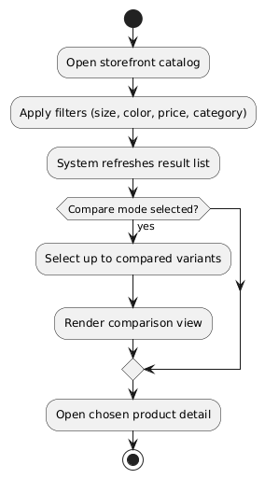
PlantUML Diagram

Business Rules
Activity | BR Code | Description
Filtering | BR37 | Multi-filter combination is supported.
Availability | BR38 | Variant-level availability is shown inline.
Comparison | BR39 | Compare view supports at least 2 selected variants.

UC14: AI recommendation chat
Name | AI recommendation chat
Description | Customer requests personalized recommendations and adds items to cart.
Actor | Customer
Trigger | Opens AI assistant and sends prompt.
Pre-condition | AI assistant service is available.
Post-condition | Recommended items are displayed and can be added to cart.

Activities Flow
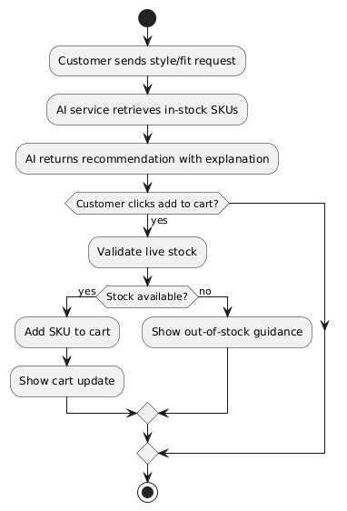
PlantUML Diagram

Business Rules
Activity | BR Code | Description
Recommendation relevance | BR40 | AI should prioritize currently available SKUs.
Explainability | BR41 | Response includes recommendation rationale.
Cart safety | BR42 | Add-to-cart action must perform stock validation at commit time.

UC15: Checkout and pay
Name | Checkout and pay
Description | Customer confirms order details and completes payment.
Actor | Customer
Trigger | Clicks Checkout from cart.
Pre-condition | Cart has valid purchasable items.
Post-condition | Order is created; payment status is stored; reservation is released/converted accordingly.

Activities Flow
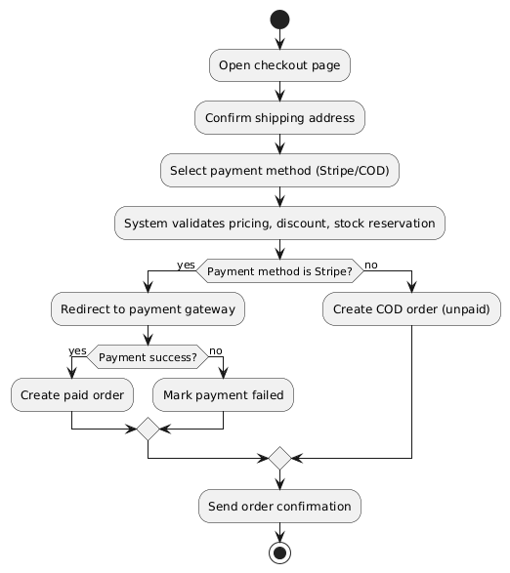
PlantUML Diagram

Business Rules
Activity | BR Code | Description
Payment options | BR43 | v1 supports Stripe and COD in online checkout.
Reservation window | BR44 | Checkout stock reservation timeout is 15 minutes.
Integrity | BR45 | Failed online payment must not produce a paid order state.

UC16: View stock by location
Name | View stock by location
Description | Customer sees SKU availability by location node display name.
Actor | Customer
Trigger | Opens product detail and selects variant.
Pre-condition | SKU and location inventory balances exist.
Post-condition | Availability list is displayed by location.

Activities Flow
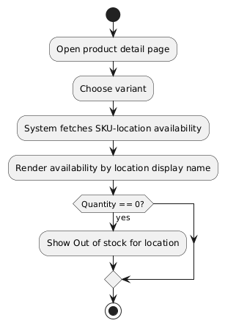
PlantUML Diagram

Business Rules
Activity | BR Code | Description
Visibility | BR46 | Customer sees location name and availability count, not internal node type labels.
Freshness | BR47 | Availability is refreshed after stock-affecting events.
Accuracy | BR48 | Quantity shown corresponds to sellable available stock.

UC17: Track shipment
Name | Track shipment
Description | Customer tracks order delivery progress from account order page.
Actor | Customer
Trigger | Opens My Orders > Order Detail.
Pre-condition | Order is confirmed and shipment object exists.
Post-condition | Shipment timeline and tracking link are shown.

Activities Flow
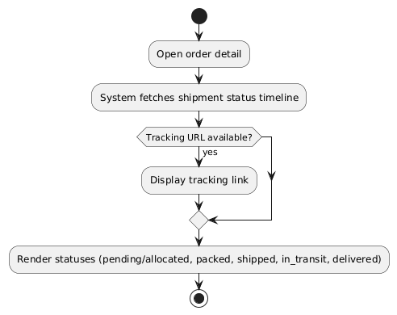
PlantUML Diagram

Business Rules
Activity | BR Code | Description
Timeline | BR49 | Minimum statuses:PENDING/ALLOCATED, PACKED, SHIPPED, IN_TRANSIT, DELIVERED.
Notifications | BR50 | Customer is notified on major shipment status transitions.
External sync | BR51 | Tracking status may be synchronized from shipping partner APIs.

UC18: Leave review with image
Name | Leave review with image
Description | Customer submits post-purchase product rating and optional images.
Actor | Customer
Trigger | Clicks Leave Review from purchased item detail.
Pre-condition | Customer purchased the item and review window is open.
Post-condition | Review is stored and appears after moderation policy passes.

Activities Flow
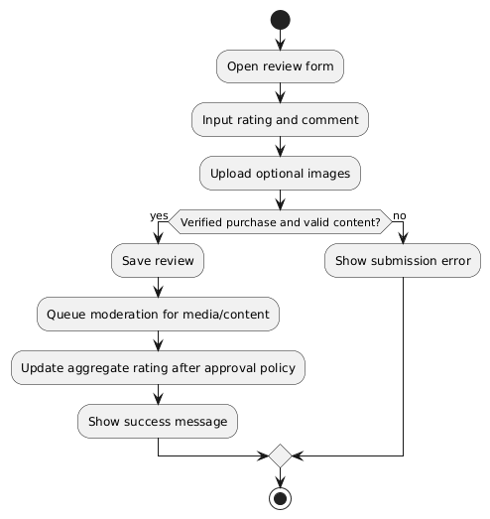
PlantUML Diagram

Business Rules
Activity | BR Code | Description
Eligibility | BR52 | Only verified purchasers can submit product reviews.
Moderation | BR53 | Image uploads are subject to moderation workflow.
Scoring | BR54 | Approved ratings contribute to product aggregate score.

UC19: View pending online orders
Name | View pending online orders
Description | Staff reviews pending orders and updates preparation status for fulfillment operations.
Actor | Authorized Staff
Trigger | Opens Orders > Pending.
Pre-condition | Staff has order.read permission and at least one order exists in actionable status.
Post-condition | Pending order list and selected order details are displayed for pick and pack processing.

Activities Flow
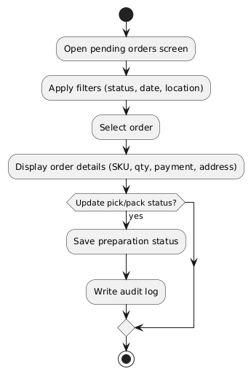
PlantUML Diagram

Business Rules
Activity | BR Code | Description
Filtering | BR55 | Staff can filter by status, date range, and fulfillment location.
Order visibility | BR56 | Order detail must include SKU lines, quantities, payment state, and address.
Preparation status | BR57 | Pick and pack status updates are auditable and role-controlled.

UC20: Mark order as shipped with tracking
Name | Mark order as shipped with tracking
Description | Staff transitions a prepared order to shipped state and sets tracking metadata.
Actor | Authorized Staff
Trigger | Clicks Mark as shipped on order detail.
Pre-condition | Order is in shippable state and staff has order.ship permission.
Post-condition | Order shipment status is updated and customer notification is sent.

Activities Flow
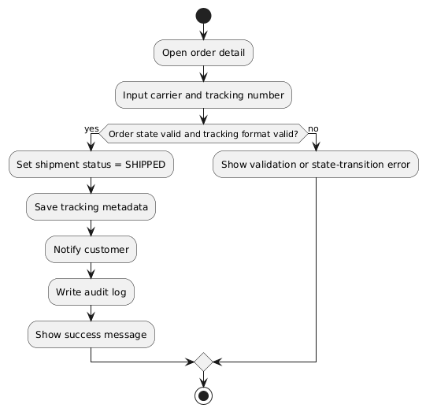
PlantUML Diagram

Business Rules
Activity | BR Code | Description
State transition | BR58 | Only eligible order states can transition to SHIPPED.
Tracking quality | BR59 | Tracking number format validation is required before shipping confirmation.
Notification | BR60 | Customer is notified immediately after successful shipping update.

UC21: Connect or reconnect Instagram account
Name | Connect or reconnect Instagram account
Description | Staff authorizes SeShop to access Instagram features for social compose operations.
Actor | Authorized Staff
Trigger | Clicks Marketing > Connect Instagram.
Pre-condition | Staff has marketing integration permission.
Post-condition | Integration token is stored securely and account connection status is updated.

Activities Flow
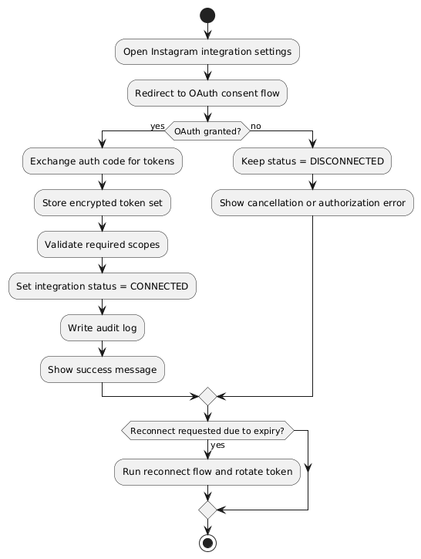
PlantUML Diagram

Business Rules
Activity | BR Code | Description
OAuth scope | BR61 | Required Instagram scopes must be validated before connection is marked active.
Token lifecycle | BR62 | Access/refresh tokens are encrypted at rest and rotated on reconnect.
Governance | BR63 | Connect/reconnect/disconnect actions are fully audited with actor metadata.

UC22: Purchase order and stock receiving
Name | Purchase order and stock receiving
Description | Staff creates purchase orders and receives inbound stock into selected locations.
Actor | Authorized Staff
Trigger | Clicks Inventory > Purchase Order.
Pre-condition | Supplier master data exists and staff has inventory procurement permission.
Post-condition | Received quantities update inventory balances and goods receipt audit entries exist.

Activities Flow
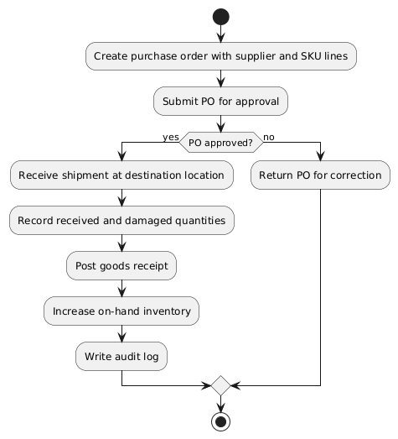
PlantUML Diagram

Business Rules
Activity | BR Code | Description
PO control | BR64 | Purchase order must include supplier, destination location, and SKU lines.
Receiving | BR65 | Received quantity can be partial and must track damaged quantity separately.
Stock posting | BR66 | Inventory increases only after goods receipt is posted successfully.

UC23: Allocate order to fulfillment location
Name | Allocate order to fulfillment location
Description | System and staff assign online order lines to optimal fulfillment location(s).
Actor | Authorized Staff
Trigger | New paid or COD order enters fulfillment queue.
Pre-condition | Order exists with sellable stock in one or more locations.
Post-condition | Allocation decision is recorded and pick tasks are generated.

Activities Flow
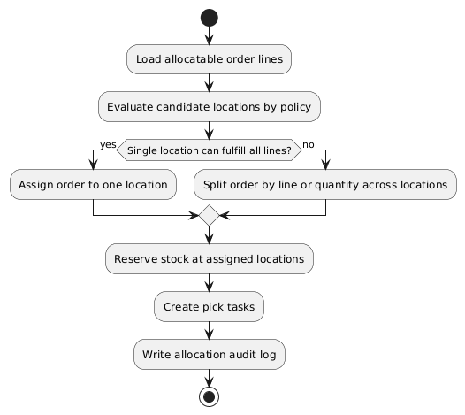
PlantUML Diagram

Business Rules
Activity | BR Code | Description
Allocation policy | BR67 | Priority order: available stock, shipping SLA, and configured location priority.
Reservation | BR68 | Allocated stock must be reserved to prevent oversell.
Split shipment | BR69 | Split shipment is allowed when one location cannot fulfill complete order.

UC24: Return intake and exchange
Name | Return intake and exchange
Description | Staff processes reverse logistics from return request to inspection and exchange.
Actor | Authorized Staff
Trigger | Customer submits return or exchange request for eligible order item.
Pre-condition | Original order item is within return window and policy scope.
Post-condition | Return disposition is completed and refund/exchange stock updates are recorded.

Activities Flow
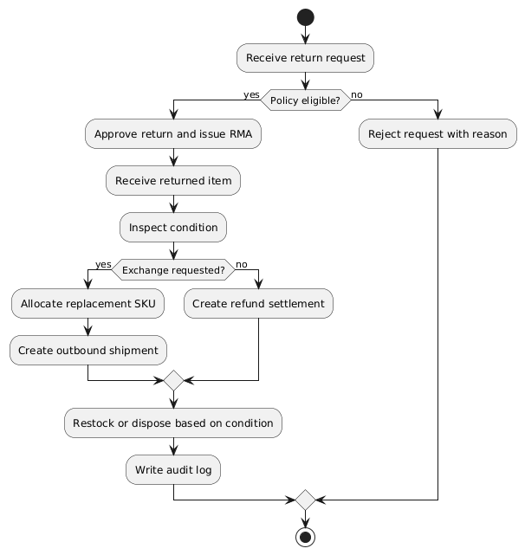
PlantUML Diagram

Business Rules
Activity | BR Code | Description
Eligibility | BR70 | Return must satisfy window, product condition, and non-final-sale constraints.
Inspection | BR71 | Disposition options: RESTOCK, REFURBISH, DISPOSE.
Exchange linkage | BR72 | Exchange order must reference original order line and RMA record.

UC25: Cycle count and inventory reconciliation
Name | Cycle count and inventory reconciliation
Description | Staff runs periodic stock counts and reconciles variances with approval workflow.
Actor | Authorized Staff
Trigger | Scheduled cycle count window starts or ad-hoc count is initiated.
Pre-condition | Count scope (location, category, SKU set) is defined.
Post-condition | Approved variances are posted and reconciliation report is generated.

Activities Flow
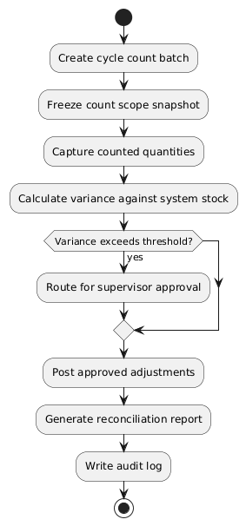
PlantUML Diagram

Business Rules
Activity | BR Code | Description
Count integrity | BR73 | Count scope snapshot must remain immutable during counting session.
Approval control | BR74 | Variance beyond threshold requires supervisor approval before posting.
Reconciliation | BR75 | System stores variance reason code and reconciliation reference for auditing.

UC26: POS shift close and cash reconciliation
Name | POS shift close and cash reconciliation
Description | Cashier closes shift, reconciles drawer, and submits discrepancy for approval if needed.
Actor | Authorized Staff
Trigger | Clicks POS > Close Shift.
Pre-condition | POS shift is open and terminal has transactions.
Post-condition | Shift summary is finalized and cash discrepancy workflow is completed.

Activities Flow
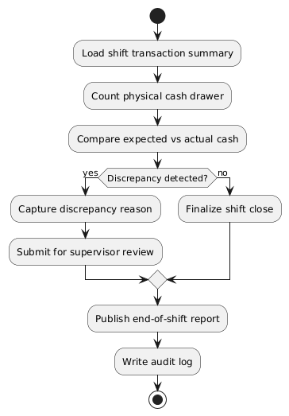
PlantUML Diagram

Business Rules
Activity | BR Code | Description
Shift closure | BR76 | Shift cannot close with pending unsaved transactions.
Cash reconciliation | BR77 | Cash variance must record reason and approver for threshold breaches.
Reporting | BR78 | End-of-shift report must include payment method totals and variance.

UC27: Generate tax invoice and adjustment note
Name | Generate tax invoice and adjustment note
Description | Staff generates compliant invoices and correction notes for online and POS orders.
Actor | Authorized Staff
Trigger | Clicks Orders/POS > Generate Invoice or Create Adjustment Note.
Pre-condition | Transaction is completed and invoice-eligible by policy.
Post-condition | Invoice or adjustment note is issued, stored, and linked to source transaction.

Activities Flow
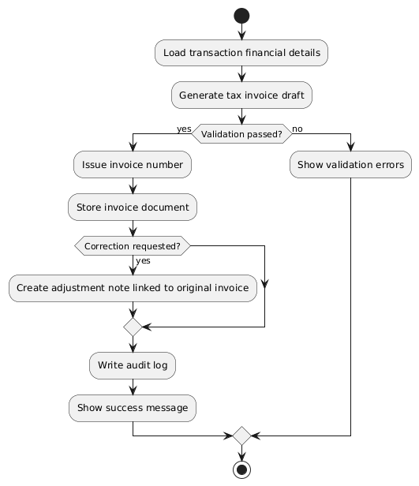
PlantUML Diagram

Business Rules
Activity | BR Code | Description
Invoice generation | BR79 | Invoice must include tax fields required by configured legal jurisdiction.
Correction process | BR80 | Adjustment note must reference original invoice and immutable reason trail.
Document integrity | BR81 | Issued financial documents are immutable and versioned by correction chain.

List Description
SeShop List Description.xlsx

View Description
SeShop View Description.xlsx

Requirements Traceability Matrix
Story ID | Story Summary | UC ID | FR ID(s) | NFR ID(s)
US-RBAC-01 | Create custom role | UC1 | FR-02 | NFR-04, NFR-05
US-RBAC-02 | Assign permissions to role | UC2 | FR-03 | NFR-04, NFR-05
US-RBAC-03, US-RBAC-04 | Assign/revoke staff role | UC3 | FR-04, FR-05 | NFR-04, NFR-05
US-RBAC-05 | View immutable audit logs | UC4 | FR-19, FR-20 | NFR-05
US-CAT-01, US-CAT-02 | Add product and SKU with social-ready media | UC5 | FR-06 | NFR-07
US-INV-01 | Adjust SKU inventory | UC6 | FR-07, FR-08 | NFR-02
US-INV-02 | Transfer stock between locations | UC7 | FR-09 | NFR-02, NFR-06
US-POS-01 | Process POS sale | UC8 | FR-12, FR-14 | NFR-02, NFR-03
US-REF-01 | Process refund | UC9 | FR-13, FR-14 | NFR-02
US-MKT-01 | Manage discount codes | UC10 | FR-15 | NFR-07
US-MKT-03 | Compose Instagram draft | UC11 | FR-16, FR-17 | NFR-07
US-CUS-01 | Register account | UC12 | FR-01 | NFR-04
US-CUS-02 | Browse and compare variants | UC13 | FR-06, FR-10 | NFR-01
US-CUS-03, US-CUS-04 | AI recommendations and add-to-cart | UC14 | FR-18 | NFR-01
US-CUS-05 | Checkout and pay | UC15 | FR-11 | NFR-02, NFR-04
US-INV-03 | View stock by location | UC16 | FR-10 | NFR-01
US-CUS-06 | Track shipment | UC17 | FR-11 | NFR-03
US-CUS-07 | Leave review with image | UC18 | FR-06 | NFR-07
US-ORD-01 | View pending online orders | UC19 | FR-11 | NFR-07
US-ORD-02 | Mark order shipped with tracking | UC20 | FR-11 | NFR-03
US-MKT-02 | Connect Instagram integration | UC21 | FR-16 | NFR-04
US-OPS-01 | Purchase order and receiving | UC22 | FR-21 | NFR-02, NFR-05
US-OPS-02 | Order allocation by location | UC23 | FR-22 | NFR-01, NFR-02
US-OPS-03 | Return intake and exchange | UC24 | FR-23 | NFR-02, NFR-07
US-OPS-04 | Cycle count reconciliation | UC25 | FR-24 | NFR-02, NFR-05
US-OPS-05 | POS shift close and cash reconciliation | UC26 | FR-25 | NFR-05, NFR-07
US-OPS-06 | Tax invoice and adjustment note | UC27 | FR-26 | NFR-05

Non-functional Requirements

3.1. User Access and Security
Function | Super Admin | Authorized Staff | Customer
Sign up / Sign in | X | X | X
Create custom role | X
Assign permission to role | X
Assign or revoke staff role | X
View audit log | X
Add product and SKUs | X | X
Adjust SKU inventory | X | X
Transfer stock | X | X
Process POS sale | X | X
Process refund | X | X
Manage discount codes | X | X
Compose Instagram draft | X | X
Connect Instagram account | X | X
View pending online orders | X | X
Mark order shipped | X | X
Purchase order and receiving | X | X
Allocate order to location | X | X
Return intake and exchange | X | X
Cycle count reconciliation | X | X
POS shift close and cash reconciliation | X | X
Generate tax invoice and adjustment note | X | X
Browse/filter variants |  |  | X
AI recommendation chat |  |  | X
Checkout and pay |  |  | X
View stock by location |  |  | X
Track shipment |  |  | X
Leave review with image |  |  | X
X: Actor has permission by default role policy. Final access is permission-driven.

3.2. Performance Requirements
Number of users
- Concurrent active users target: 500 concurrent users.
- Registered business users and customers growth: scalable without schema redesign.
Data volume
- Product and media data expected to grow continuously with campaign seasons.
- Inventory and order event streams are high-frequency write paths.
Performance targets
- 95th percentile product search/filter response <= 2 seconds.
- Inventory update commit latency target <= 500 ms for standard operations.
Availability target
- Core commerce services target 99.9% monthly availability.

3.3. Implementation Requirements
Location
Ho Chi Minh City
Read-only Duration
Maximum 2 hours during planned maintenance windows
Read-only Timeframe
Sunday 23:00 (local timezone), if required by release activity
Maintenance Window
Weekly planned maintenance on Sunday night with prior notice and rollback plan
Overall conversion timeline
Milestone releases on agreed sprint boundaries
Language and localization policy
- Customer-facing and back-office UI shall support Vietnamese and English.
- Message definitions in this SRS are canonical intent strings; implementation must provide localized vi and en variants.

Appendixes

Glossary
Term | Description
BR | Business Rule
BRD | Business Requirements Document
NFR | Non-functional Requirement
RBAC | Role-Based Access Control
SKU | Stock Keeping Unit
POS | Point of Sale
SRS | Software Requirements Specification
UC | Use Case
MSG | Message
TBD | To Be Determined

Messages
All messages must be localized for both vi and en in implementation.
Message Code | Message Content | Button
MSG 1 | Are you sure you want to continue this action? | OK/Cancel
MSG 2 | Required fields are missing. Please complete all mandatory inputs.
MSG 3 | Role created successfully.
MSG 4 | Permissions assigned successfully.
MSG 5 | Staff role assignment updated successfully.
MSG 6 | You do not have permission for this action.
MSG 7 | Product and SKU created successfully.
MSG 8 | Inventory adjusted successfully.
MSG 9 | Inventory transfer created successfully.
MSG 10 | POS sale completed successfully.
MSG 11 | Refund processed successfully.
MSG 12 | Discount code saved successfully.
MSG 13 | Instagram draft saved successfully.
MSG 14 | Registration successful. Please verify your account.
MSG 15 | AI recommendation added to cart successfully.
MSG 16 | Payment completed successfully.
MSG 17 | Payment failed. Please retry or choose another method.
MSG 18 | Tracking information is currently unavailable.
MSG 19 | Review submitted successfully.
MSG 20 | Duplicate code or identifier detected.
MSG 21 | Invalid input format detected.
MSG 22 | Insufficient stock for requested operation.
MSG 23 | Purchase order created successfully.
MSG 24 | Goods receipt posted successfully.
MSG 25 | Order allocation completed successfully.
MSG 26 | Return or exchange processed successfully.
MSG 27 | Shift close submitted with reconciliation result.
MSG 28 | Tax invoice or adjustment note issued successfully.

Issues List
- Resolved: External shipment provider webhook contract and retry policy are implemented and verified.
- Resolved: AI recommendation safety policy for user prompts and output filtering is enforced.
- Resolved: Final bilingual message catalog (Vietnamese, English) is approved and deployed for production.

